Ecology Report

{

Project Preservation

Group - 5

Group members:

Talha Shamim CS19B050

Shubham raj CE30B030

Saurav Gwalia CS19b035

Rajendra Kumar CS19B034

Navjot Singh CS19B030

P. Anurag CS19B031

Naman Sharma CS19B029

Deepika CS19B027

Vikas Meena CE19B032

V.V.S Reddy CS19B040

}

**Abstract**

Through this riveting and interactive web page, we made a garbage and cleanliness complaint section which will work as an order and delivery system in which local citizens can file an online complaint which will be redirected to their respective local municipal corporation. Another nifty thing we showed with global intermediaries is API’s which counsel people for sustainability like rise in the sea level and global temperature working as a climate time machine. Inclusion of global carbon dioxide footprint will agonize people for the future. Site also provides all basic apprehensions of sustainability intentions. The enticing tree diagrams, images , and animations are manifested on site that will be tantalizing people’s conception for viability.

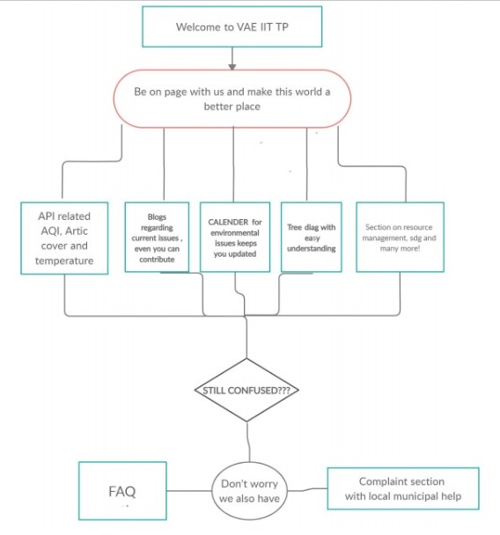

**Introduction and Literature Review**

The major environmental problem today is to reduce carbon footprint or carbon emissions. Mostly, this is managed at an industry level but to really reduce the carbon emissions we have to manage it at individual level. So, the local people are highly responsible for their environment.

We have made a website to convince and help local people to reduce their carbon emissions. This website is more user friendly and interactive than the other website out there on the internet. People should know how they are contributing to carbon emissions, what is its impact on the environment, how it is ruining their environment and what can be its solutions.

The informative part of the website mainly focuses on type of resources (renewable and non-renewable), sustainable development and SDGs (Sustainable Development Goals).

* In the resources section it explains about the merits and demerits of renewable and non-renewable resources in a more attractive way. It explains the things using an animated tree diagram which conveys the information in form of text and pictures which make it more understandable and user friendly.
* It also has the Sustainable development section in which it explains what is sustainable development and what are its goals. All the 17 sustainable development goals are listed and discussed.

* Calendar – This calendar has the information about all the environmental events of the year.

Climate Time Machine

The data of “Climate Time Machine” is taken from NASA. It provides the data of the following:

* CO2 Emissions - This shows the CO2 (in trillion kg) in the atmosphere in a particular year. Users can simply search the year and it shows the amount of CO2 present in the atmosphere in that year. For example – if a user wants to know the amount of CO2 present in the atmosphere in 2010, he can simply search and it shows the data of 2010.

* Arctic Ice Extent – It shows the area of earth’s surface covered by ice (in million square km). At first glance, it may not be so important until you consider the fact that all the ice which disappeared will add itself to the ocean and increase the sea level.What makes this even serious is the matter that quite a large percentage of people live in near coastal areas, and low altitude area and just a rise in few meters are enough to cover about 20-28 % of total land area.
* Global Temperature Change – It takes the reference of temperature in 1880 and tells the change in temperature of a specific year with respect to 1880 (In degrees Fahrenheit). The planet’s average temperature has risen about 2.05 degrees Fahrenheit (1.14 degrees Celsius) since the late 19th century.

Air Quality Index

In this section users can know the Air Quality Index (AQI) of a city. It uses color coding for better understanding, if the AQI of a city is high or air is highly polluted it shows the result in red color and if the air is less polluted it shows the result in green color. It also shows the environmental impacts and precautions according to the AQI of the city user has searched for.

For the latest update of data of AQI, the website uses API (Application Programming Interface), it automatically updates the data when the host website is updated.

Complaints Section

The website has a section in which a user can complain about the garbage management and cleanliness in their locality and his/her complaint is redirected to the local municipal corporation.

Blog

In this section users can create their own blog and also can read the blogs of other users which makes the website more interactive at user level. It provides a platform for the users where they can post environmental problems, discuss and can suggest some solutions.

Literature Review

There are many organizations and websites working to reduce the carbon footprint or carbon emissions for the better environment. We found that data and information on many websites is not understandable by everyone as it includes many technical terms and complexity in data representation. We decided to make the information more attractive using animations and pictures with the text and representing the data in a more understandable way. So, the website has tools which help the common people to know how they are contributing to carbon emissions, what is its impact on the environment, how it is ruining their environment and what can be its solutions.

The two more important features of the website are the complaint and blog section of the website. In the complaint section of the website work as an order and delivery system in which local citizens will file an online complaint which will be redirected to their respective local municipal corporation. This helps the people to make their locality clean and also helps municipal corporation in garbage collection. In the blog section users can create their own blog and also can read the blogs of other users which makes the website more interactive at user level. It provides a platform for the users where they can post environmental problems, discuss and can suggest some solutions.

There are many projects working in this area but still we are not able to change things one of the example is the SWATCH BHARAT ABHIYAN aimed majorly at open defecation but even after such a huge investment and advertisement we have not able to reach all the people, So what’s most important is that we must change the perspective of the people when we want to take an issue which do not directly benefit people and will benefit in long term.

**Methodology**

Our methodology was oriented towards changing the mindset of local people towards the environment in a much more user friendly and interactive way by building a simple and intuitive website. In the start,to find a problem which we could solve,we had some brainstorming sessions and we conducted surveys at our local level to find out why despite there being so much effort by voluntary and government organizations, the conditions are not improving. We found out that many people still lacked awareness on the environmental problems and how unknowingly they were being affected and also contributing to it.To tackle these problems , we used qualitative and quantitative approaches to make people aware of basic knowledge of environment and sustainability.

We conducted surveys at our own local level to assess the situation and analysed the results.The questions were asked by physically going to local villages.

In the survey we conducted, we asked people questions on various aspects of their life like:

* What was the fuel they were using for their daily activities like cooking?
* Did they know about sustainable development?
* What did they know about air pollution?
* Where were they dumping the waste?
* Were they using plastic and if yes, were they burning it after use?
* Were they burning their waste or their fields?
* Did they know that they are being exposed to health problems due to air pollution either coming from outside or from the one they are generating themselves either while cooking or while burning waste?
* Did they know what problems the whole world is facing right now?
* If possible , are they ready to do what’s necessary to improve the situation at their end?

Before building anything, we thoroughly analysed the results of the survey and tried to figure out what is the best solution we could come up with to improve the situation.Most of the people were dumping the waste in open or burning it, many were still using traditional methods of cooking, they were dumping their plastic by burning it or by dumping in the fields. We understood that making people aware of the harmful effects of such practices was not going to help much. So, it was decided that apart from the data presented on the website, simple and easy to understand solutions to various problems will also be provided which people can implement at their own homes without any difficulties.

We figured out that the usual awareness programs about the environment don’t reach these people.But since we also knew that almost everybody had smartphones these days, we decided to build a website since most of the websites out there are simply too advanced for these people to understand. Since we cannot physically go to every village in the country, it was assumed that the situation was more or less the same for all the local villages. The basic and probably the biggest assumption that was taken was that these people can read simple plain English which would be enough for us to pass on the knowledge of the environment from the world out there to them. It was decided that this was a fairly reasonable assumption as they can already use smartphones.

The data was collected from various trustworthy sources like NASA, World Air Quality Index website,UNEP,UN,fao.org , iflscience.org.

The data collected was used to build a user friendly website. We tried to keep the mathematical details a little more abstract but displayed it both in a qualitative and quantitative way. We used colourful graphs to display the comparison among datas accumulated. Various pictures were included in the site to make the website more intuitive. To get the latest information from trusted sources without any copyright issues and also update the data regularly on our website, we used API(Application Programming Interface).The benefit of this was that whenever the latest data is updated on the host websites, our website will fetch the updated data without the need of manually updating the information.The would ensure that our website always provides the updated information to our users. A local complaint section was also added wherein people can write the complaints about their area to municipalities such as someone burning or dumping the waste in the open, someone burning the plastic in open etc. The users of the website can also contact us about any suggestions or assistance they want from us.

Apart from the above mentioned information, various pages are dedicated to showing the benefit and meaning of sustainability , use of renewable resources, resource management techniques, sustainable development goals, importance of protecting the environment etc.

**Tests and discussions**

# homepage:-

* The website is more of its most crucial aspect since it was the user sees first, and it should leave a good impression on the user.
* The homepage starts with simple facts and related photos to not make the user burdened with information from the very start.

# website structure:-

* There are two main parts of the website, which are about sustainable development goals and renewable and non -renewable resources.
* Then there are other parts of the website, which are city API, climate time-machine, and calendar.
* Then there is a blog and complaint section.

## Sustainability development goals:-

* This section has been given emphasized because of the completeness of SDG.This covers all the sdg with proper explanation and illustrative pictures which will not only be helpful for highly literate persons rather it will be understood by general public.
* Most of the people don’t even have heard about these things then how can we expect them to contribute to this side.
* Hence we have tried to take this to individual level.

renewable and nonrenewable resources:-

* The website home page ends with renewable and non -renewable resources.
* On the website, there are pictures of examples of renewable and nonrenewable resources which when opened give detailed explanation about their impact and consequences on the environment and our future.
* Non - renewable resources are limited in nature and either take millions of years to form or don't form at all, and hence when we run out of them there is nothing we can do about them.
* But renewable resources, on the other hand, will be inextinguishable or at least will recover quickly enough.
* On paper, it may seem easy to think everybody should directly adopt renewable resource. However, there are two problems we are facing, which are that renewable resources are still developing and not readily available and second is the fact that current society is addicted to nonrenewable resources.
* The first problem is being taken care of by scientists and for the second part, what is required is awareness which is where our website comes in.
* The website clearly explains the merits and demerits of renewable and nonrenewable resources in a simple manner.

City API:-

* The city API shows AQ [air quality index of a city being searched for.
* It also gives information about the pollution level, health implications and cautionary statements.
* Its most significant merit is that instead of showering the user with a lot of info, it is concise and allows comparison of different cities in a more straightforward manner.

# climate time machine:-

* The motive behind the diagrams is to show the user how the environment has degraded in the past few years in a simplistic approach.
* The main aim here is not to overwhelm the user with large quantity but rather to make the user observe the change himself, unlike other information first methods.

Arctic ice:-

* This part of the website shows the arctic ice area in different years.
* At first glance, it may not be so important until you consider the fact that all the ice which disappeared will add itself to the ocean and increase the sea level.
* What makes this even serious is the matter that quite a large percentage of people live in near coastal areas, and low altitude area and just a rise in few meters are enough to cover about 20-28 % of total land area.
* One advantage of using arctic ice over other calculative models is that it is less affected by short terms than other methods, i.e. it is the final result of the culmination of all extensive climate changes and environmental degradation.

CO2:-

* this part of the website shows the amount of co2 present in the atmosphere in ppm in different years.
* Although it is quite well known about carbon footprint, its importance can't is neglected.
* The website gives a straightforward comparison in the diagrams without confusing the user about regional differences and not so important information.

Global temperature difference:-

* this part of the website shows the temperature difference of a region and also of the whole world in different years.
* Here the temperature difference was measured by comparing that to that of in the year 1880.
* this the most detailed one in a climate time machine because unlike the other two, the temperature is highly subject to all types of environmental events and also because local and global values have their value in different ways in this case.
* This is an integral part of the website since temperature difference is highly dynamic and thus, an essential tool.

# 

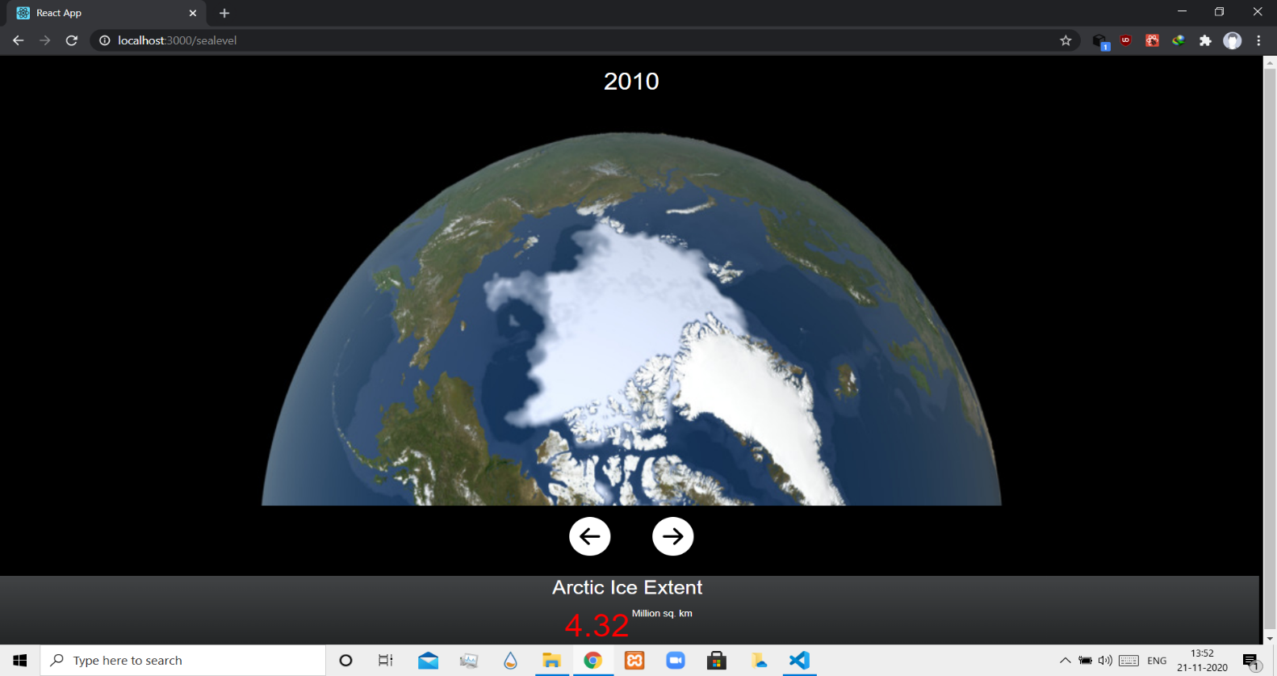

# Calender:-

* This is the last informative feature of the website.
* Unlike all previous parts of the website, it is something for user act.
* It marks various environmental events of the years in a simple manner.
* Most user users will forget the information they gained in previous parts of the website, but at least a small amount of users will partake in the events.
* Seeing people who participate in these events, many more people will join these events, thus spreading the word.

# Blog:-

* This is the part of the website which contains articles made by the user.
* Since this is continuously updated, it will provide new information much faster than traditional methods.

# Complaints section:-

* This is part of the website which takes advice and complaints of the user.
* This information then is used to improve the website.

*Conclusion*:

* Sustainability in simple terms means our ability to live our entire lives with the right amount of consumption of resources from the food we eat, the water we drink to the clothes we wear and to the petrol we fill the tanks with and much more.
* Simple measures and efforts could lead us to a more sustainable way of living without compromising on our luxuries.
* We have provided data on different ways to use renewable, non-renewable resources, and different parameters on sustainable use of resources and accept it in daily life.
* Our environment needs to be protected and conserved. Conservation of our nature is significant as it sustains us.
* Following the three "R's" to conserve natural resources and land. Educate. We are trying to help others understand the importance and value of our natural resources.
* Human health and economic health are inextricably linked to the health of our planet-saving nature is really about saving ourselves.
* COVID-19 lockdown pandemic has desired positive effects on nature like drastic reduction in global coal production (estimated to have decreased by 2.2% from 2018), the number of birds has been found to increase by 3-fold up to some 3,000, Environmental noise pollution has reduced (industrial activities, transportation, etc), air quality has improved to a great extent(based on AQI)
* We have collected data using API’s on Arctic ice extent, CO2 Emissions, Global Temperature Change all over the world in the past few decades, this can help you know that we are at an extreme position of the destruction of our planet.
* Timely action and awareness have helped to reverse the damages made to the environment. We should therefore continue to contribute towards greener earth in whichever way we can.
* Through our website, we are trying to spread this awareness to people so it comes alive in the minds and hearts of each one of us to save this beautiful and serene land of traditions.

Resources:

Sdgs.un.org

[www.unep.org](http://www.unep.org)

[www.nasa.org](http://www.nasa.org)

climate.nasa.org

climate.nasa.gov

fao.org

iflscience.org

waqi.info